Prof. Dr. Christof Wetterich

Personal Information
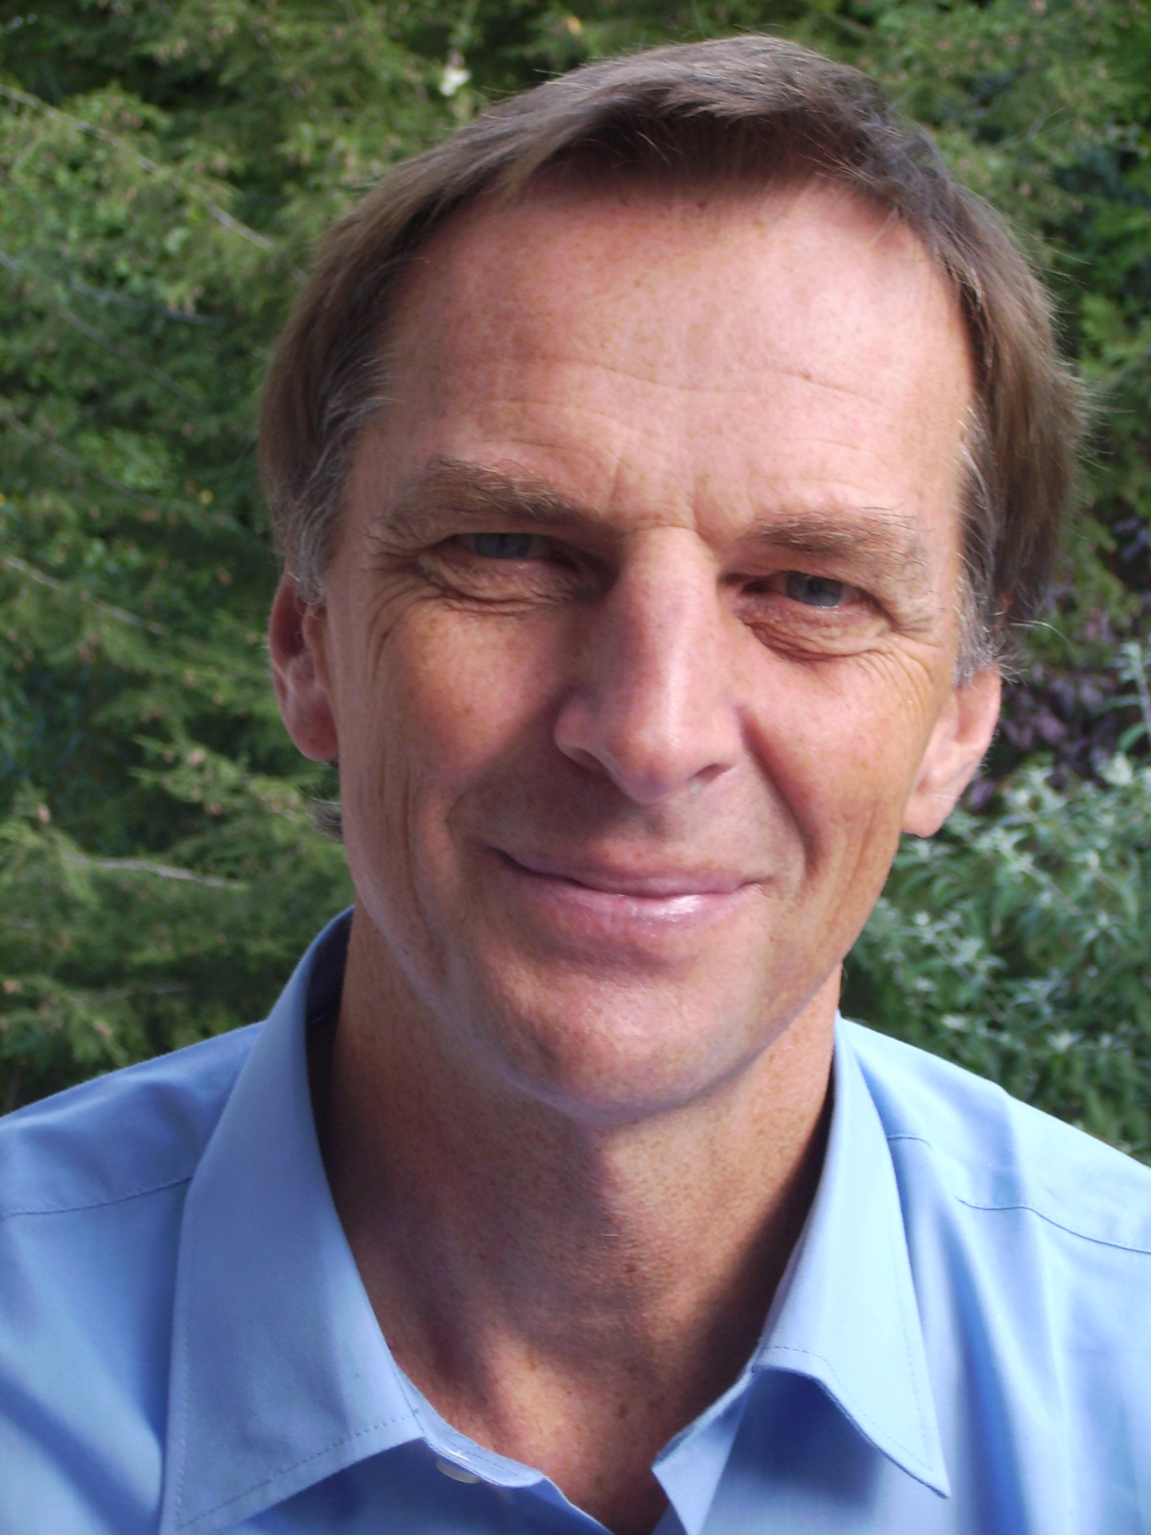

Address: Institut für Theoretische Physik Heidelberg
Philosophenweg 16
69120 Heidelberg
E-Mail: C.Wetterich@ThPhys.uni-heidelberg.de
Phone: +496221/549-340
Date: April 12, 1952, Freiburg

Scientific Career and International Experience

2006-: External Member, MPI for Nuclear Physics, HD
1999-2000: Dean, Faculty of Physics and Astronomy
1992-: Universität Heidelberg, chair of theoretical physics
1985-1992: DESY (Hamburg), permanent staff
1985: Heisenberg Stipendium (at CERN)
1983-1985: Universität Bern
1983: Habilitation (Universität Freiburg)
1981-1983: Fellow at CERN (Geneva)
1979: Dissertation (PhD) (summa cum laude)
1977-1981: Employed by the University of Freiburg
1972-1978: Studies in Physics at Université Paris VII, University of Cologne,
University of Freiburg, Diploma 1978

Main Research Fields

Cosmology: First proposal of a dynamical Dark Energy (quintessence) (1987).
Proposal of Dark Energy – Dark Matter coupling (1995).
Investigation of time variation of fundamental constants in quintessence models (1987). Analysis of the role of Early Dark Energy for CMB and structure formation. Possible solution of “why now problem for dark energy” by growing neutrino mass. Inflation as transition from higher dimensions to effective four dimensions (1983, with Q. Shafi). Cosmon inflation. Universe without expansion.
Great emptiness in the beginning of the Universe.

Particle Physics: Neutrino masses and oscillations, proposal of triplet mechanism as
alternative to seesaw.
Explanation of three generations of quarks and leptons by higher dimensional chirality index (1983) (e.g. used in superstring theories).
Spinor gravity as proposal for quantum gravity.

Quantum Gravity: Prediction of Higgs boson mass from asymptotic safety (with M. Shaposhnikov).
Gauge invariant flow equation.
Quantum scale symmetry.

Development Modern form of functional renormalization (effective average action)
of new methods: (1993).

Quantum theory: Emergence of quantum physics from classical statistics. Quantum computing with classical bits.

Phase transitions: Proposal of crossover replacing electroweak phase transition (1983, with M. Reuter). Investigations of transition to quark gluon plasma.

Non-equilibrium Proposal of prethermalization (2004, with J. Berges, St.Borsanyi)
Quantum Field
Theory:

Ultracold atoms: Investigation of BCS-BEC crossover by functional renormalization.

Service to the Community

2006 - 2019: Member Academic Advisory Committee, Heidelberg University
2006 - 2017: Speaker, Transregional Project TRR33 “The Dark Universe” (Bonn, Heidelberg, Munich)
1998 - 2008: Member Selection Committee for Alexander von Humboldt Awards
1996 - 1998: Member Scientific Council DESY

Stipends, Awards and Honours

2019: Gentner-Kastler Prize
2014: Gutenberg professorship Mainz
2012: ERC Advanced Grant
2006: Member, Heidelberger Akademie der Wissenschaften
2005. Max-Planck Research Prize
1985: Heisenberg Stipendium
1979: Goedecke Prize

Ten Important Publications

C. Wetterich: Cosmology and the fate of dilatation symmetry, Nucl. Phys. B, 302, 668 (1988), arXiv:1711.03844

C. Wetterich: Exact evolution equation for effective potential, Phys. Lett. B301, 90-94 (1993), arXiv:1710.05815

G. Lazarides, Q. Shafi, C. Wetterich: Proton lifetime and fermion masses in an SO(10) model, Nucl. Phys. B, 181, 287 (1981),

C. Wetterich: The cosmon model for an asymptotically vanishing time dependent cosmological ‘constant’, Astron. Astrophys., 301, 321-328 (1995), arXiv:hep-th/9408025

C. Wetterich: Crossover quintessence and cosmological history of fundamental constants,
Phys. Lett. B, 561, 10-16 (2003), arXiv:hep-ph/0301261

J. Berges, Sz. Borsányi, C. Wetterich: Prethermalization, Phys. Rev. Lett., 93, 142002 (2004), arXiv:hep-ph/0403234

P. Braun-Munzinger, J. Stachel, C. Wetterich: Chemical freeze-out and the QCD phase transition temperature, Phys. Lett. B, 596, 61 (2004), arXiv:nucl-th/0311005

L. Amendola, M. Baldi, C. Wetterich: Quintessence cosmologies with a growing matter component, Phys. Rev. D78, 023015 (2008), arXiv:0706.3064

C. Wetterich: Quantum scale symmetry, arXiv:1901.04741

M. Shaposhnikov, C. Wetterich: Asymptotic safety of gravity and the Higgs boson mass, Phys. Lett. B 683 (2010) 196, arXiv:0912.0208

